FUNCTION APPROXIMATION USING A MULTILAYER PERCEPTRON (MLP)

Internship Progress Report – Version 1
Author: Ayshan Gambarli
University: Eötvös Loránd University (ELTE), Faculty of Informatics
Internship Institution: Institute of Control Systems, Azerbaijan
Version: 1
Date: July 2026
1. Problem Definition
The mathematical function selected for approximation is f(x₁,x₂)=5x₁²+7x₁x₂−x₂²−x₁+x₂+5 Where x_1​ and x_2​ are input variables. The objective of the neural network is to learn this nonlinear relationship directly from generated data and predict the function output as accurately as possible.
2. Dataset Generation
A synthetic dataset was generated in Python.
For each sample:
random values of x_1​ and x_2​ were generated from the interval [−1,1] The exact function value f(x) was then calculated. To simulate measurement uncertainty, a random noise variable δ was generated. Different noise levels were introduced using y=f(x)(1+αδ) where α=0,0.01,0.03,0.05 represents the noise coefficient. A total of 500 samples were generated. The generated data were stored in
- dataset.csv
- train.csv
- test.csv
The generated dataset was divided into 400 training samples and 100 testing samples.

3. Neural Network Architecture
Parameter | Value
Input neurons | 2
Hidden neurons | 5
Output neurons | 1
Activation | Sigmoid
Optimizer | Adam
Epochs | 2000
The neural network was implemented using the TensorFlow/Keras framework. The architecture consists of:

4. Training Process

The network was trained for 2000 epochs. During training, the loss function continuously decreased, indicating that the model gradually learned the relationship between the input variables and the target function. The learning process was monitored using the Mean Squared Error (MSE) loss function and the Mean Absolute Error (MAE) metric.

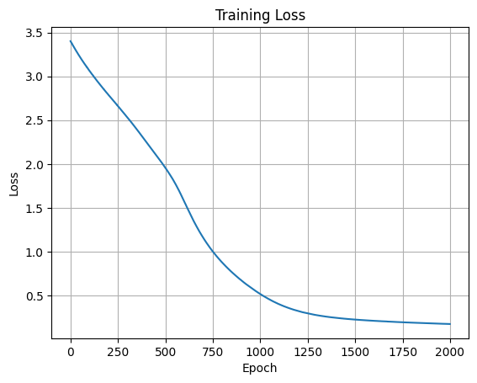
The Training Loss graph shows a rapid decrease during the first epochs, followed by a gradual convergence. This behaviour indicates successful optimization of the network parameters. 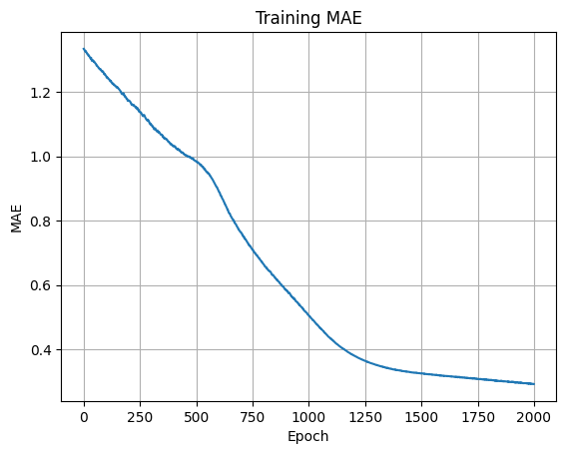
The MAE graph follows a similar trend, decreasing steadily as training progresses. This confirms that prediction accuracy improves throughout the learning process.
5. Model Evaluation
After training, the model was evaluated using both the training dataset and the testing dataset.
Metric | Value
MSE | 0.1741
MAE | 0.2917
Metric | Value
MSE | 0.4037
MAE | 0.4052

Training Results Testing Results
The testing error is slightly larger than the training error, which is expected because the testing data were not used during model training.
The difference between training and testing performance remains relatively small, indicating that the model generalizes reasonably well.

6. Prediction Results

The trained model was used to predict the output values for the testing dataset. The predicted values were compared with the true function values.

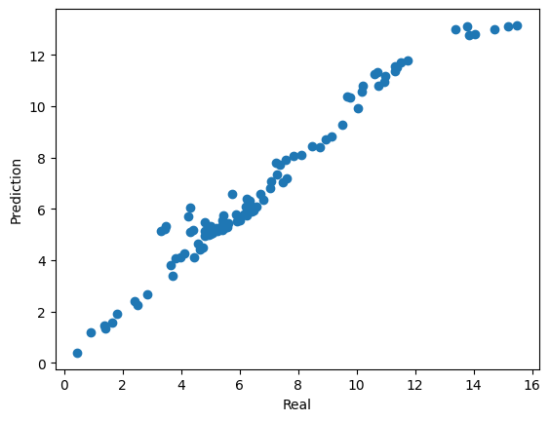
The scatter plot demonstrates that most prediction points lie close to the ideal diagonal line. This indicates that the neural network successfully approximates the nonlinear mathematical function.

7. Discussion

The first implementation of the Multilayer Perceptron successfully learned the nonlinear relationship between the input variables and the target function. The obtained results indicate that the selected architecture is capable of modelling the target function with relatively small prediction errors.

8. Work Completed
- Generated the dataset.
- Built the MLP model.
- Trained and evaluated the network.
- Visualized the results.
9. Conclusion
Version 1 demonstrates the successful implementation of an MLP for nonlinear function approximation. Future work will focus on MAPE, backpropagation, and model optimization.

